**UID/UX**

**SHERYL KATRINA.M**

**CSE – D**

**230701310**

**Comparison of UI/UX Design Between Two Figma Creations**

* **BAD DESIGN PROTOTYPE :**

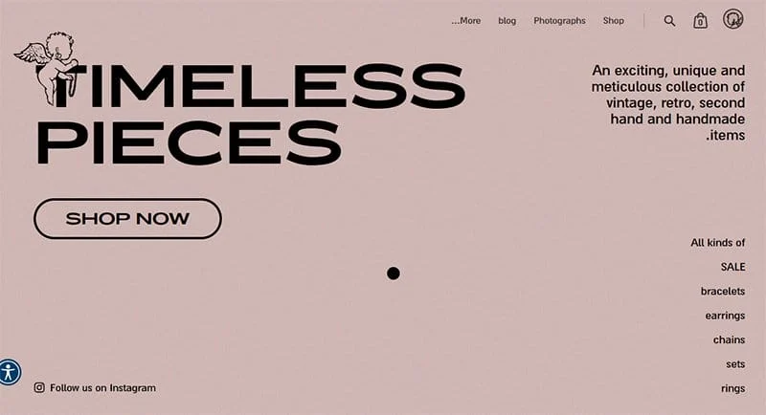

* **GOOD DESIGN PROTOTYPE:**

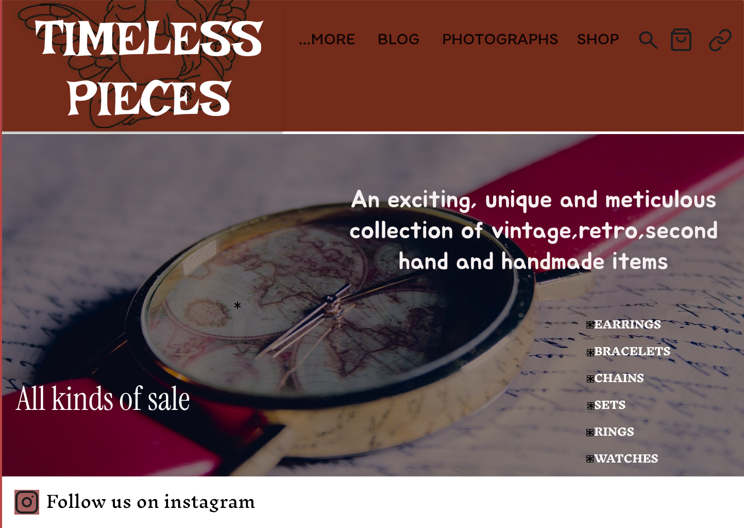

**Comparison of UI/UX Design Between Two Figma Creations**

**Overall Design Differences**

The two images show different versions of an e-commerce website for "Timeless Pieces." One is minimalist and modern, while the other is more visually appealing and aesthetic. The differences between these designs show the most important aspects of UI/UX design, such as typography, color gradient, layout, and imagery.

**Typography and Font Style**

**First Design (Classic Version):** It is a bold sans-serif font with high contrast, but it will be very outstanding and somehow rigid, not beautiful.

**Second Design (Updated Version):** It applies a serif font, which is artistic in style. The text has curvy, stylized typography that is regarded to capture the vintage look. That will somewhat enhance readability and give a classic, timeless expression as well.

**Importance of Style:**

The font will set the mood and branding of a website. The first design is too modern and doesn't have the personality, but the second one does a perfect job of depicting the vintage and retro theme.

Serif gives a more sophisticated and elegant look, which can be used in a brand dealing with handmade and antique pieces.

**Color Gradient and Visual Appeal**

**First Design:** There's a neutral beige background used against black text that doesn't really add much depth or engagement.

**Second Design:** This design features a rich, warm gradient of brown that warms up character. This is immediately nostalgic and luxurious, so fitting to the theme - vintage and handcrafted jewelry.

**Why Color Matters in UI/UX**

A well-thought color scheme improves brand recall and emotional connection.

Neutral and warm tones in the second design give the shopping experience to be cozy and premium.

Contrast in the first design has made it readable but fails to provide an emotional warmth required to make a good user experience.

**Use of Imagery and Layout**

**First Design**: The absence of a highlighted product image with only text has resulted in this. The big "SHOP NOW" button has helped in the call-to-action, but feels disjointed.

**Second Design**: Has a visual appealing hero of a retro watch, right on brand with the product.

**Why Imagery Is So Important:**

Users interact more with images rather than text. The second design has a lifestyle image that allows users to see the brand's personality.

If the image is strong, the site will retain visitors and convert them better because it is more engaging.

**Navigation and UX Enhancements**

**First Design**: The menu items are more spread out and not very organized.

**Second Design**: Uses a menu that is more structured and well-defined in terms of hierarchy. Categories like earrings, bracelets, and watches are emphasized to enhance discoverability.

**UI/UX Best Practices:**

* Clear navigation results in an easier user experience and fewer bounce rates.
* The second design layout encourages easy browsing and thus more engagement with users.

**Social Media Integration & Call to Action**

**First Design:** It has a tiny "Follow us on Instagram" button, but it's not visually prominent.

**Second Design:** It has an Instagram call-to-action clearly designed with an icon, so it is much more noticeable.

**Why This Matters:**

Social media integration is very important for brand engagement. A well-placed CTA can drive traffic and increase brand loyalty.

**Conclusion**

The second design is much better than the first as it uses a better font style, warm color scheme, and strong imagery to improve navigation. These features improve the UI/UX experience and make the website more user-friendly, aesthetically pleasing, and engaging. Understanding these differences will help designers create more effective and visually appealing digital experiences that align with the brand's identity and user expectations.